

*java iot developer Lab*

Lab -5

**SUBMITTED BY: SUBMITTED TO:**

**AYUSH KUMAR JHA Dr. SURBHI SARASWAT**

**SAP ID - 500086400**

**Enrollment no - R200220083**

**B.C.A -I.O.T.**

Questions :-

Q1. Blink LED without using Delay().

// C++ code

//

const long interval = 1000;

int ledState = LOW;

unsigned long previousMillis = 0;

int buttonState = 0;

void setup()

{

pinMode(2, INPUT);

pinMode(8, OUTPUT);

}

void loop()

{

// read the state of the pushbutton value

buttonState = digitalRead(2);

// check if pushbutton is pressed. if it is, the

// buttonState is HIGH

unsigned long currentMillis = millis();

if (buttonState == HIGH) {

if (currentMillis - previousMillis >= interval) {

// save the last time you blinked the LED

previousMillis = currentMillis;

// if the LED is off turn it on and vice-versa:

if (ledState == LOW) {

ledState = HIGH;

} else {

ledState = LOW;

}

// set the LED with the ledState of the variable:

digitalWrite(8, ledState);

}

} else {

// turn LED off

digitalWrite(8, LOW);

}

// Delay a little bit to improve simulation performance

delay(10);

}

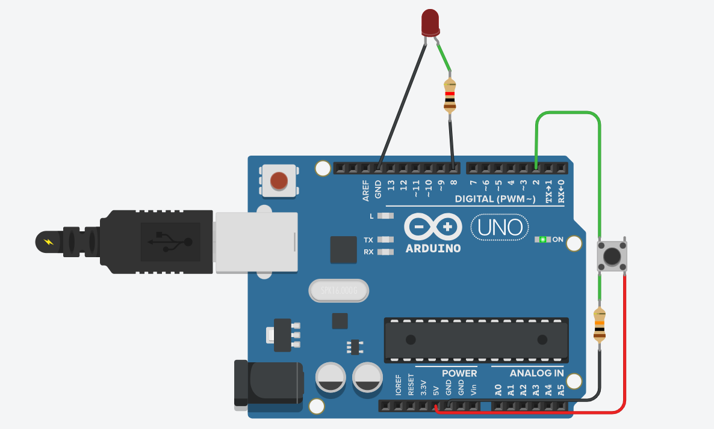

Q2. Use one slider/ toggle switch and two LEDs.

// C++ code

//

int buttonState = 0;

void setup()

{

pinMode(2, INPUT);

pinMode(8, OUTPUT);

pinMode(5, OUTPUT);

}

void loop()

{

// read the state of the pushbutton value

buttonState = digitalRead(2);

// check if pushbutton is pressed. if it is, the

// buttonState is HIGH

if (buttonState == HIGH) {

// turn LED on

digitalWrite(8, HIGH);

digitalWrite(5,LOW);

} else {

// turn LED off

digitalWrite(8, LOW);

digitalWrite(5,HIGH);

}

// Delay a little bit to improve simulation performance

delay(10);

}

